



ULTRA COLLEGE OF ENGINEERING
AND TECHNOLOGY

Department Of Information Technology

Completed a project on

Educational Organisation System Using

ServiceNow
Submitted By

Team ID : NM2025TMID00121
- Team Leader : Marliyathul Nafra M
- Team Member : Agnes J
- Team Member : Thasbina Nasrin S
- Team Member : Velchandrapraba M


ANNA UNIVERSTY: CHENNAI 600025

BONAFIDE CERTIFICATE
Certified that this project report “EDUCATION ORGANISATION USING SERVICENOW”
is the Bonafide work of M.MARLIYATHUL NAFRA(912922205012), J.AGNES(912922205001),S.THASBINANASRIN(912922205019),
M.VELCHANDRAPRABA(912922205021), who carried out the project work under my supervision.

SIGNATURE SIGNATURE
MRS.U. THIRUNIRAISELVI M.E MRS.M.KARUPPU ROJA
HEAD OF THE DEPARTMENT ASSOCIATE PROFESSOR
Department of Information Technology Department of Information Technology
Ultra College of Engineering and Technology Ultra College of Engineering and Technology
Madurai-625104 Madurai-625104

Submitted for the Project Viva-Voice held on…………………….

Internal Examiner External Examiner

Educational Organisation System Using ServiceNow
1.INTRODUCTION

Project Overview
The Educational Management System is a unified digital platform built on ServiceNow, aimed at optimizing core administrative tasks within educational institutions. It simplifies the management of student information, course enrollments, admission procedures, and academic progress monitoring through automated and structured workflows.

Purpose
The goal of this project is to eliminate inefficient, manual administrative tasks by introducing digital workflows powered by ServiceNow. It focuses on improving transparency, streamlining approval procedures, and enabling prompt communication between students and academic staff.
2.IDEATION PHASE

Problem Statement
Educational institutions often struggle with fragmented and manual handling of admissions, student data, and academic processes. Delays and miscommunication affect both students and staff.

User Insight Map
- Who are the users?
Students, faculty members, and academic administration staff.
- What do they think or feel?
Students often feel uncertain about their application progress, while staff struggle with handling excessive paperwork.
- What do they see?
Disorganized records, long queues, and outdated paper-driven processes.
- What do they say or do?
Frequently ask for updates and rely on submitting or managing physical documents.
- What do they hear?
Complaints and dissatisfaction regarding delays and lack of proper communication.

Brainstorming
Considered:
After evaluating options like Excel-based logs and manual registers, ServiceNow was selected for its structured workflow engine and scalability.
3. REQUIREMENT ANALYSIS

Student Journey Map
Student logs in → Applies for admission/course → System triggers approval → Faculty and HOD approve → Notification sent → Admission or enrollment confirmed

Solution Requirements
To support a streamlined and fully automated educational service request system, the following elements were implemented:
- Custom Service Catalog: Titled "Educational Services" to group all student-related requests.
- Categorization: Services were organized into logical groups—Admissions, Academics, and Student Support.
- Catalog Items: Included key student services such as Admission Application, ID Card Request, and Grade Report Access.
- Role-Based Permissions: Defined access levels for students, faculty members, and administrators.
- Custom Data Tables: Created dedicated tables to manage admission records and track academic progress.
- Multi-Level Approval Workflows: Enabled systematic review and approval at different stages (e.g., faculty and HOD).
- Automated Notifications: Configured email alerts for both approvals and rejections to keep users informed in real time.

Data Flow Diagram
User→Service Portal→Catalog→Request Form→Workflow→Task Table→ Notification → Mail → User/Group

Technology Stack
- Platform: ServiceNow
- Scripts: JavaScript (Glide APIs), HTML
- Modules: Service Catalog, Workflow Editor, Notifications, Tables, Access Control
4. PROJECT DESIGN

Problem-Solution Fit
Traditional academic workflows often suffer from delays, lack of visibility, and inefficiencies due to their manual nature. This solution addresses these challenges by introducing categorized service catalog items, automated approval processes, and real-time notification systems - significantly enhancing operational efficiency and the overall student experience.

Proposed Solution
To resolve the identified issues, the project incorporated the following key components:
- Catalog: A dedicated catalog named Educational Services was created.
- Categories: Organized into Admissions, Academics, and Student Support to simplify access and navigation.
- Catalog Items: Included essential services such as Admission Requests, ID Card Applications, and Grade Reports.
- Custom Role: Custom roles like student_role and faculty_role were defined to assign specific access privileges.
- Groups: An Academic Office group was established to manage and process requests.
- Custom Tables: Custom tables (u_admission and u_student_progress) were created to store and manage student-related data.
- Workflows: Approval processes were structured into multiple levels with final confirmation tasks to ensure proper review.
- Notifications: Email alerts were configured to keep users updated about request statuses throughout the workflow.

Solution Architecture

- Frontend Interface: Utilized the Service Portal for user interactions and service requests.
- Logic Layer: Implemented business logic using Workflow Editor and UI Policies for conditional form behavior.
- Backend Structure: Included custom data tables and dictionary entries to support data storage and management.
- Notification Framework: Dynamic HTML email templates were used to notify users of approvals or rejections.
- Access Control Mechanism: Role-based permissions ensured that users could only access features relevant to their roles.

5. PROJECT PLANNING & SCHEDULING
During this stage, the overall project was divided into smaller, well-defined phases to ensure modular development, systematic validation, and smooth deployment. The major tasks performed included:
- Catalog Initialization: A dedicated catalog titled "Educational Services" was established as the centralized hub for all student and staff service requests.
- Category Design: Categories such as Admissions, Academics, and Support were added for logical grouping of services.
- Item Configuration: Each catalog item (Admission, ID Card Request, Grade Report) was added with detailed descriptions, associated forms, and images where required.
- User and Role Configuration: Roles including student_role and faculty_role were created and linked to specific users. Additionally, the Academic Office group was assigned responsibilities for backend processing.
- Table Design: Custom tables (u_admission, u_student_progress) were created and structured with fields for capturing relevant data like student grades, contact information, application status, etc.
- Workflow Development: Approval workflows were set up involving faculty and HOD, followed by backend task handling by academic office members.
- Portal and Interface Setup: The Service Portal was configured for visibility of catalog items, form interactivity, and access control based on user roles.
- Notification Integration: Email notifications were designed using HTML templates to inform users about approval/rejection status with dynamic content.
- Manual Testing: Each functionality was tested step-by-step to ensure consistency, correctness, and complete process coverage.

6. IMPLEMENTATION WORKFLOW
This phase outlines the sequence of steps performed in implementing the Educational Management System:
Step 1: Setting Up ServiceNow Instance
- Sign up for a developer account on the ServiceNow Developer site “https://developer.servicenow.com”.
- Once logged in, navigate to the "Personal Developer Instance" section.
- Click on "Request Instance" to create a new ServiceNow instance.
- Fill out the required information and submit the request.
- You'll receive an email with the instance details once it's ready.
- Log in to your ServiceNow instance using the provided credentials.
- Now you will navigate to the ServiceNow
Step 2: Create a Update Set
- Click on All >> Local update sets.
- Click on new
- Enter the Details Name: Educational Organisation >> Click on Submit and make Current
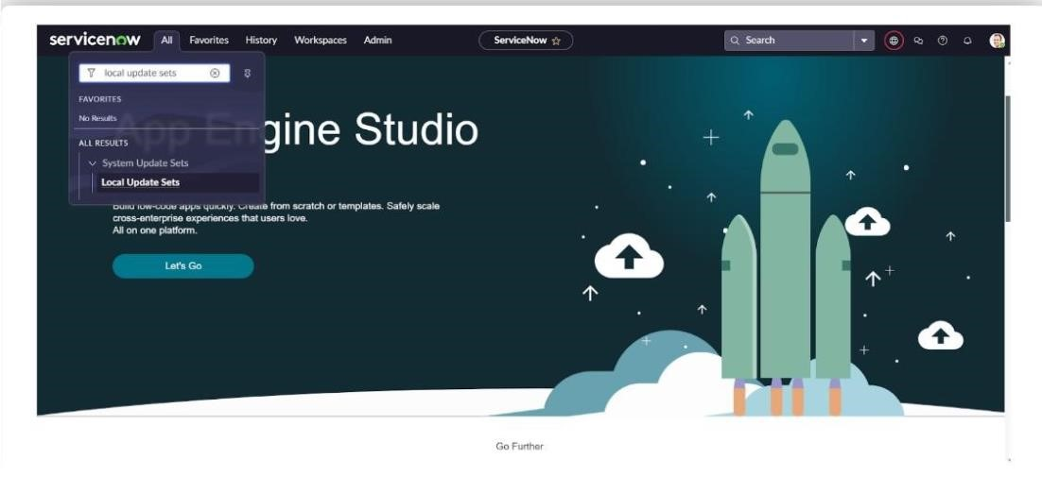
Step 3: Create a Table
- All >> Tables.
- Click New
- Enter the Label (Anything you want): Salesforce >> Click on Name it will Automatically generate Api name
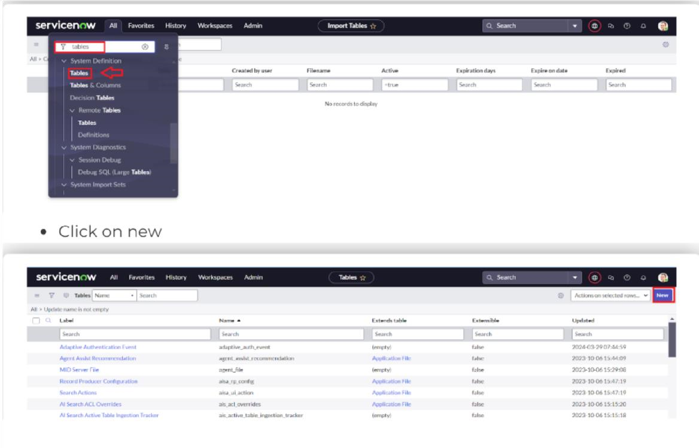
Step 4: Create Admission Table
- Create an Admission Table with Columns given.
- Select Extends Table >> Salesforce and also Select Add module to menu >> Salesforce. • Create Fields as shown
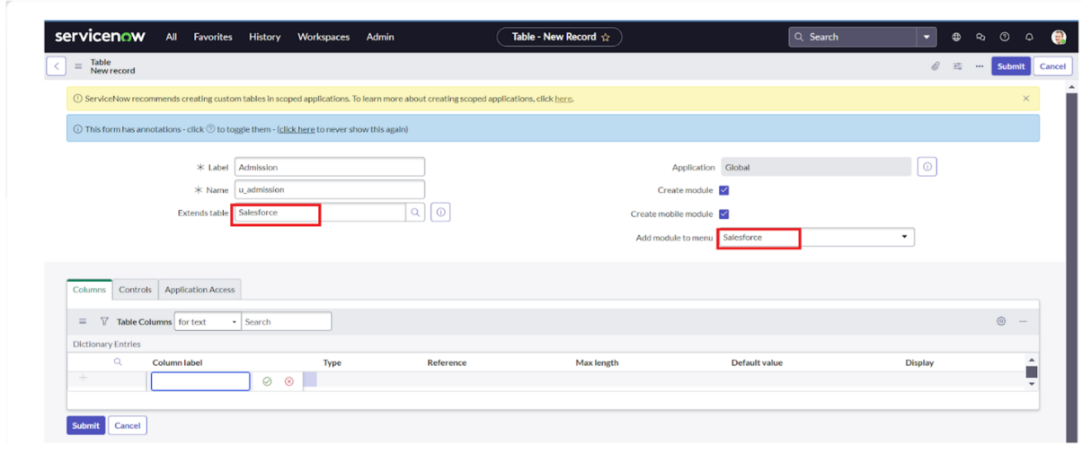
Step 5: Create Student Progress Table
- Create a Student Progress Table with Columns given.
- Select Add module to menu >> Salesforce.
- Create Fields as shown:
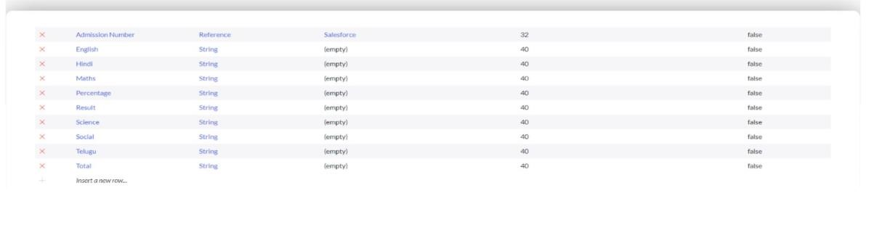

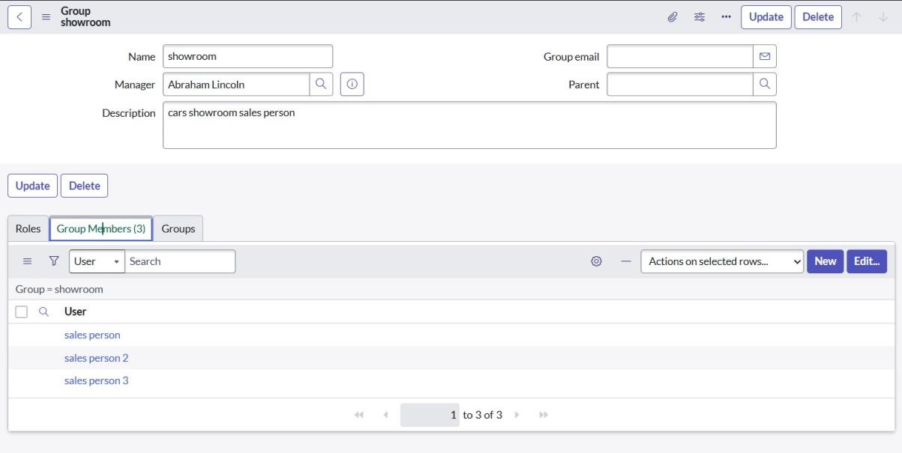
Step 6: Configuring Table form for Student Progress Table
- In the Student Progress Table Page, Click on Layout form.
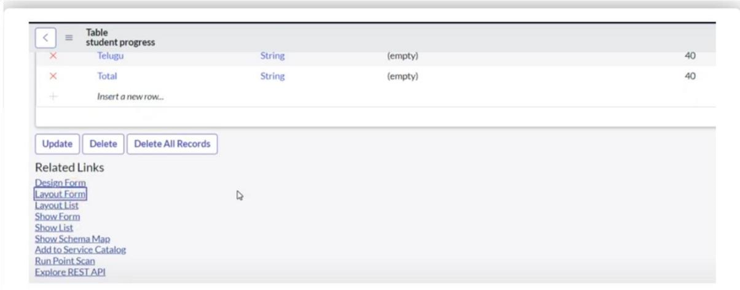
Step 7: Creating Form Design For Sales Force Table
- All >> System Definition >> Tables.
- In Label Search for Salesforce and open.
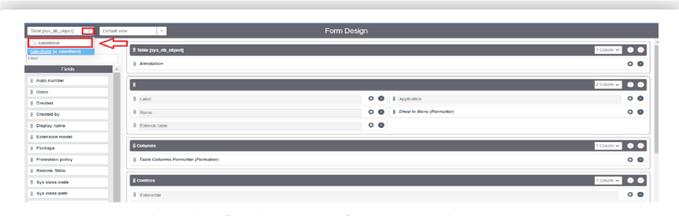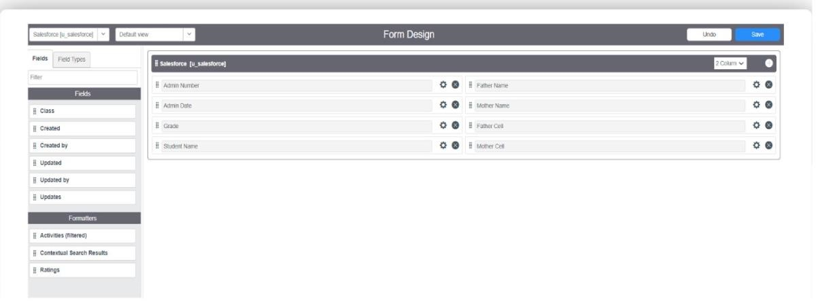

Task: Creating Form Design For Admission Table
Follow the same steps as Activity1, Configure the fields as below and Save.
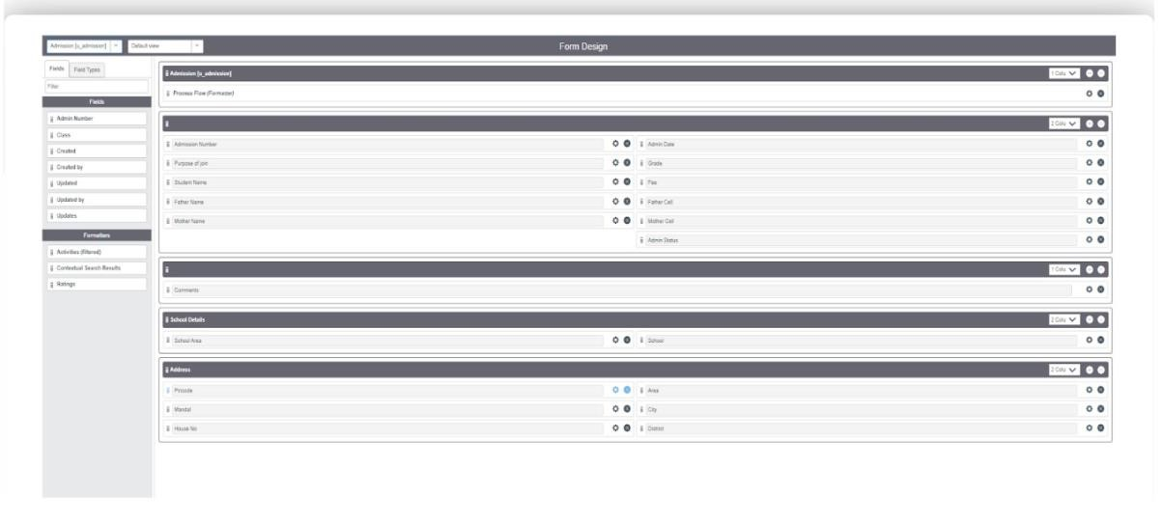
Task: Creating Form Design For Student Progress Table

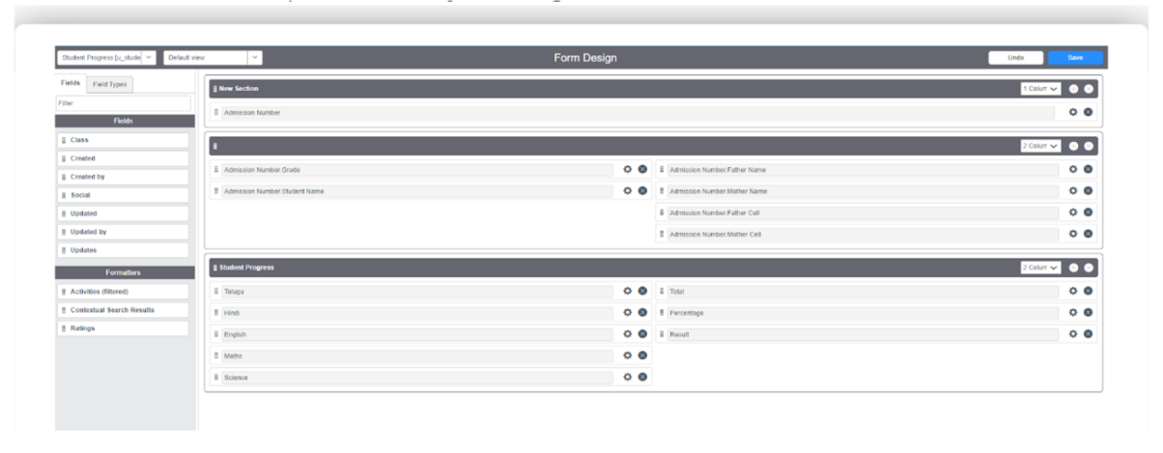
- Task: Creating Number Maintenance For Admin Number
- All >> Number Maintenance >> New • Fill the details >> Submit.
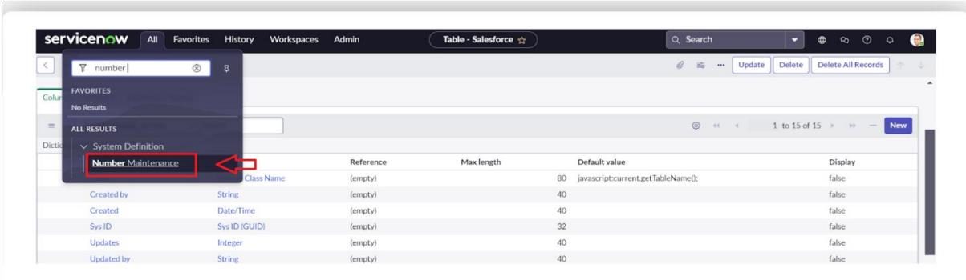
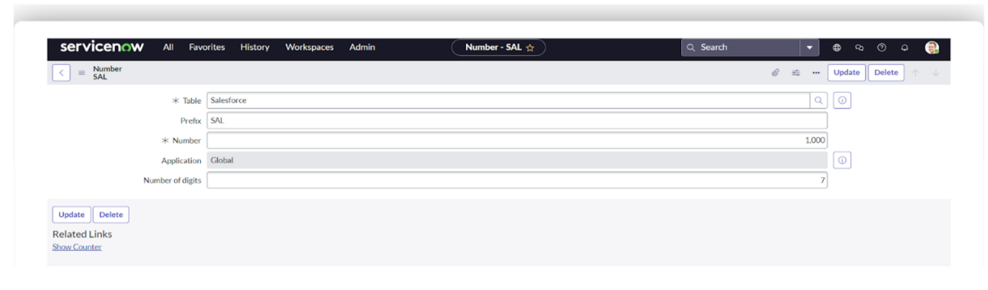
- Notification: Creating Process Flow For Admission Table
- All >> Process Flow>> New.
- Fill the Details as given Below
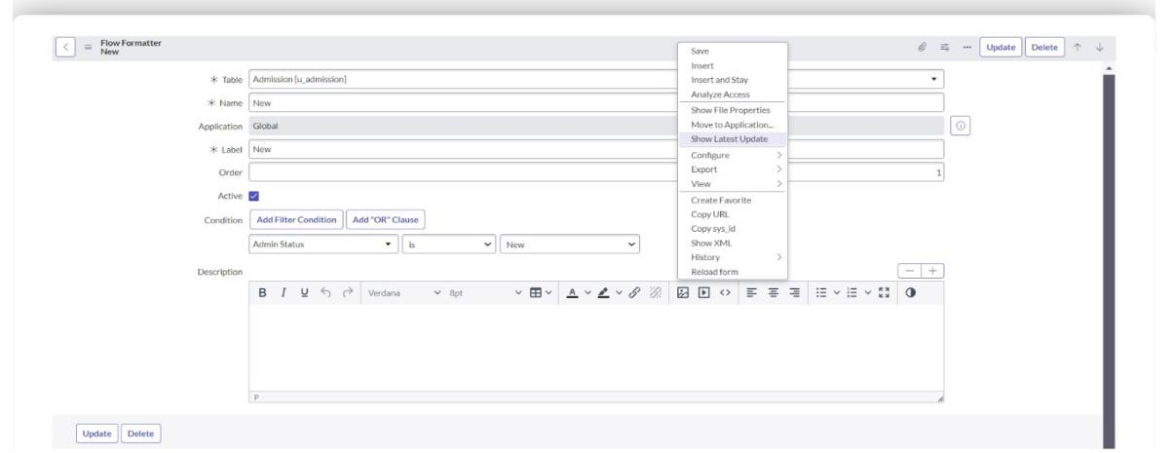
- Right Click on toggle and click on the save .
- Replace the Name and Label as below and click on Insert on stay.
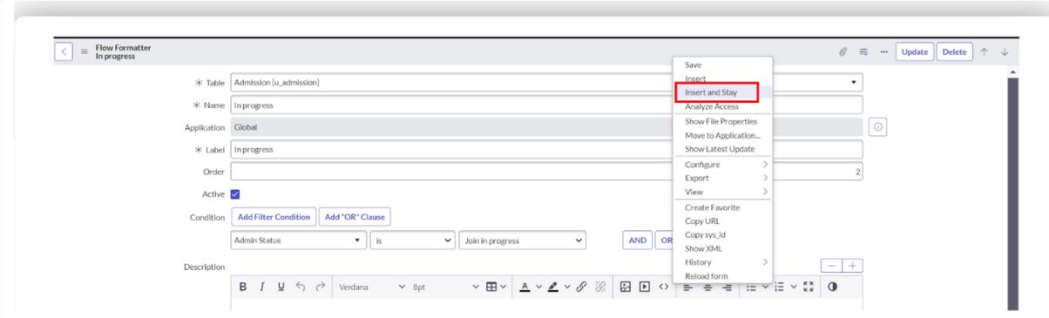
- Replace the Name and Label in order and click on Insert on stay. Joined >> Rejected >> Rejoined >> Closed >> Cancelled.
- Order should be New >> InProgress >> Joined >> Rejected >> Rejoined >> Closed >> Cancelled.
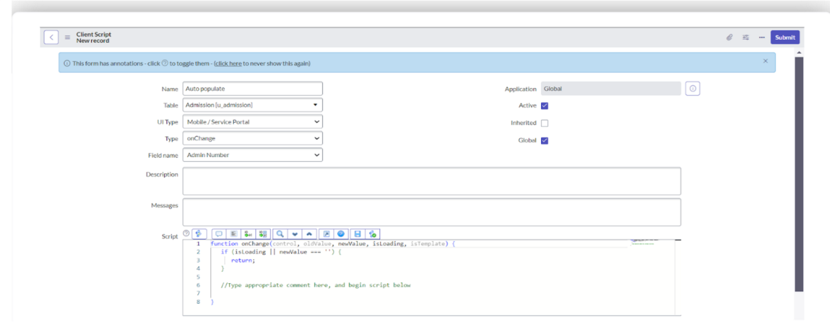
- Task: Client Script
- All >> Client Scripts >> New.
- Fill the Details as given.

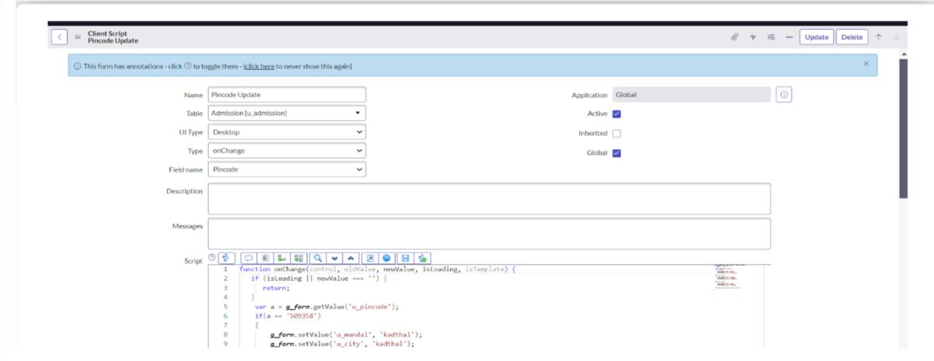

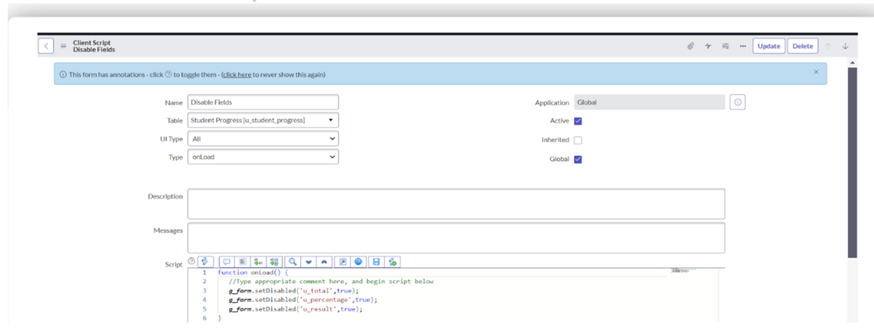

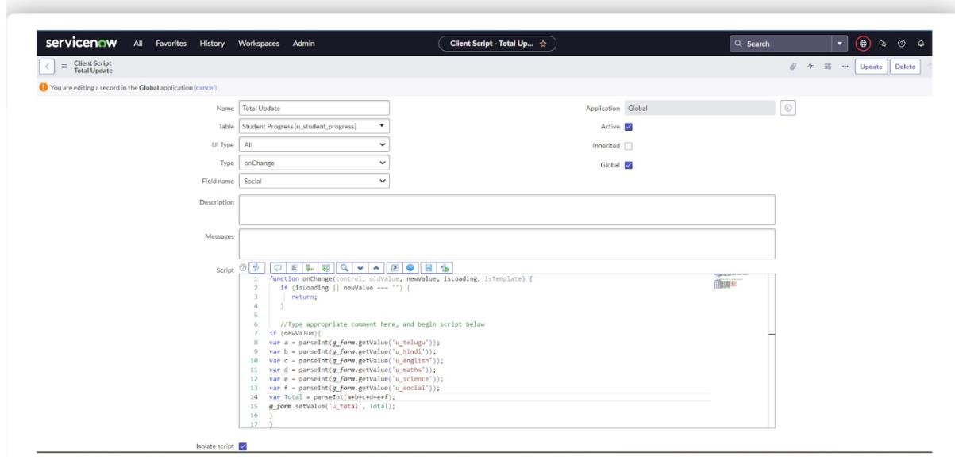
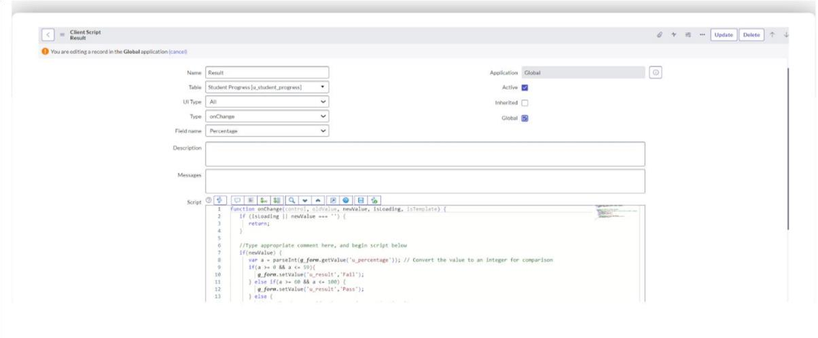
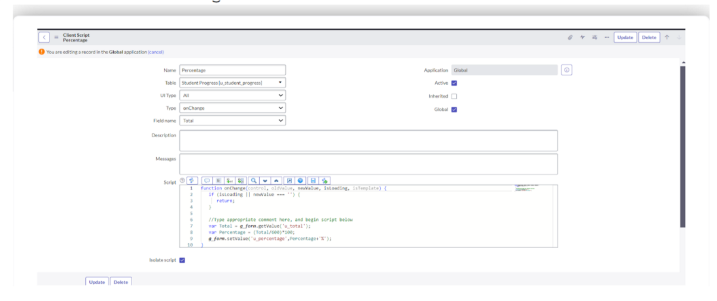

Result:
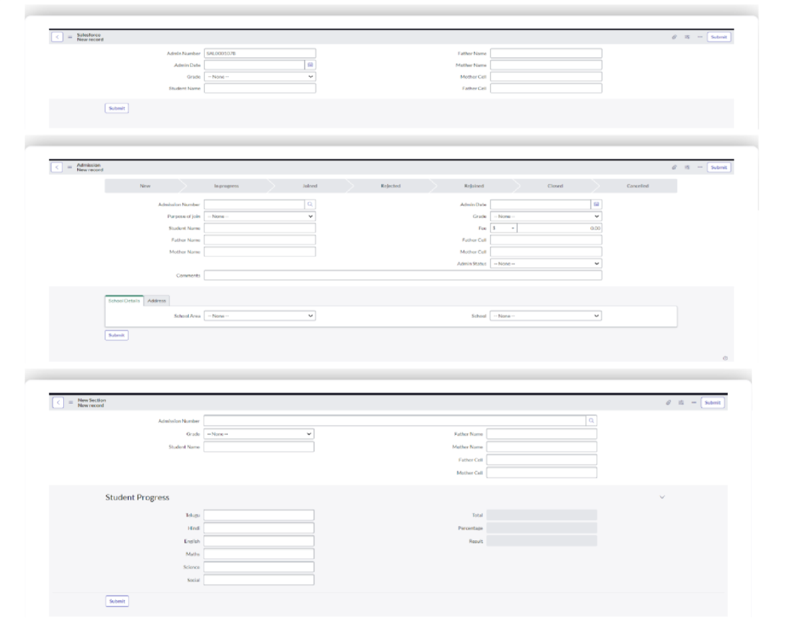
7. FUNCTIONAL AND PERFORMANCE TESTING

Performance Testing
Performance and Functional Testing involved checking every module and step in the workflow. Key validations included:
- Catalog Display: All items and categories visible under "Educational Services".
- Form Accuracy: Fields loaded correctly and accepted valid inputs.
- Workflow Execution: Requests routed to appropriate approvers with state tracking.
- Email Delivery: Notifications triggered instantly with correct content.
- Data Consistency: Entries correctly updated in u_admission and u_student_progress tables.

8. ADVANTAGEDISADVANTAGES

Advantages
- Improved Efficiency: Reduces manual work and speeds up request handling.
- Error Reduction: Validations prevent incorrect data entries.
- Real-Time Notifications: Keeps stakeholders updated at each stage.
- Scalability: Future academic services can be added easily without structural overhaul.

Limitations
- Dependency on ServiceNow Expertise: Requires administrators familiar with platform scripting and configuration.
- Initial Complexity: Workflow setup and portal tuning may take considerable time during the first phase.

9. CONCLUSION
The Educational Management System developed using ServiceNow provides an integrated, scalable, and efficient solution for managing key academic workflows such as admissions, progress tracking, and student support. It ensures structured communication, automated approvals, and transparent operations, enhancing the overall student and faculty experience.

10. FUTURE SCOPE
To make the system more robust and comprehensive, the following enhancements are proposed:
- Feedback Module: Allow students to rate and provide feedback on services or academic support.
- Role-Based Dashboards: Interactive dashboards for admin, teachers, and students with metrics and analytics.
- Messaging Integration: Notify students via WhatsApp or SMS in addition to emails.
- Bulk Operations: Enable mass course enrollment, attendance tracking, and batch promotions.
- Payment Gateway Integration: Allow students to pay application or tuition fees through the portal securely.

